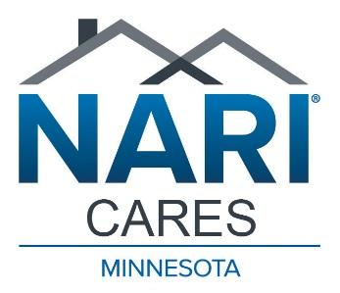 NARI Cares Project Proposal

Individual or Organization Name and Address
Primary Contact Name, Phone, Email
Organization Mission/Focus
Project Name and Address Year Built
Property Owners Name
Type of Insurance on the property & Insurance Co. Name
Project Description/Need
Who will this project benefit and how?
Available materials or funds
Any restrictions on when the project can be performed
Organization or Homeowner willing to sign a liability waiver?
Organization and Homeowner willing to sign a media release including photos, quotes, etc?
Organization and Homeowner willing to speak to the NARI membership either live or on video?
Organization and Homeowner willing to help promote NARI Cares and the project?

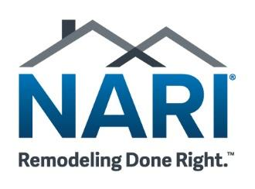 NARI Cares Project Proposal

- NARI Cares is associated with the Minnesota Chapter of the National Association of the Remodeling Industry (NARI). We are able to utilize the skills and generosity of NARI members to generate donations or discounts on material and labor and can therefore reduce the cost of your project.

- The NARI Cares Committee will identify a Project Contractor from our membership who will work with you and NARI Cares to complete the project. You will need to sign a contract with the Project Contractor stating the scope of the work and any financial responsibilities.

- In many cases, there is some level of participation in the overall cost of the project by you, the recipient, either through special fundraisers, assistance in securing donations or volunteer labor.

- All communications (media, social media, signage, press release, etc.) related to the project will mention NARI Cares, and signage, brochures, fliers and other printed materials will include the NARI Cares logo. You may be asked to mention or use the logo of NARI member companies who donate significantly to your project. You will provide information related to your organization and the project to NARI Cares for use in promotion and community awareness.

- NARI Cares will be the fiscal agent for all project related donations. All donations of cash, material or services, will go through NARI Cares as the 501(c)(3) fiscal agent. Someone from your organization will be named as the primary point of contact between your organization, NARI Cares and the Project Contractor.

- Include with this form any supporting documentation such as a detailed project description, bids, spec sheets, drawings, organization information, etc.

- If your project is selected for further consideration, someone from the NARI Cares Committee will contact you for further discussion.

