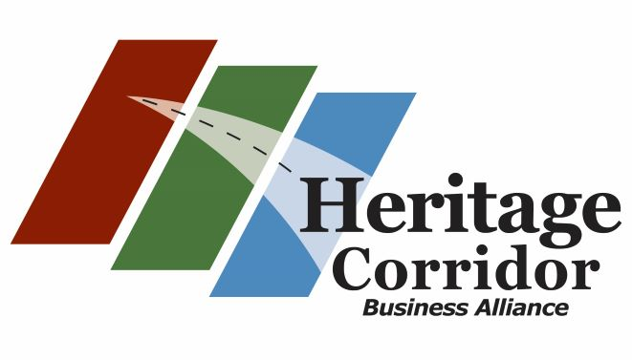

As a valued member of the Heritage Corridor Business Alliance you are cordially invited to attend the Heritage Corridor Business Alliance Retirement & Lifestyle Wellness Program Presentation. This event is FREE to all HCBA Members so if you are looking for either a new retirement or health care program for you and your employees please mark your calendar to attend!
When: Wednesday January 22nd, 2020
4:30pm-6:30pm

Where: The Lemont Public Library
50 East Wend Street
Lemont, IL
Deadline to RSVP: Monday January 20th:

Email kathy@MyHCBA.com or call the HCBA Office at (630) 257-5997

